Technical Datasheet of WIN-PiHAT-16DI
1. Overview
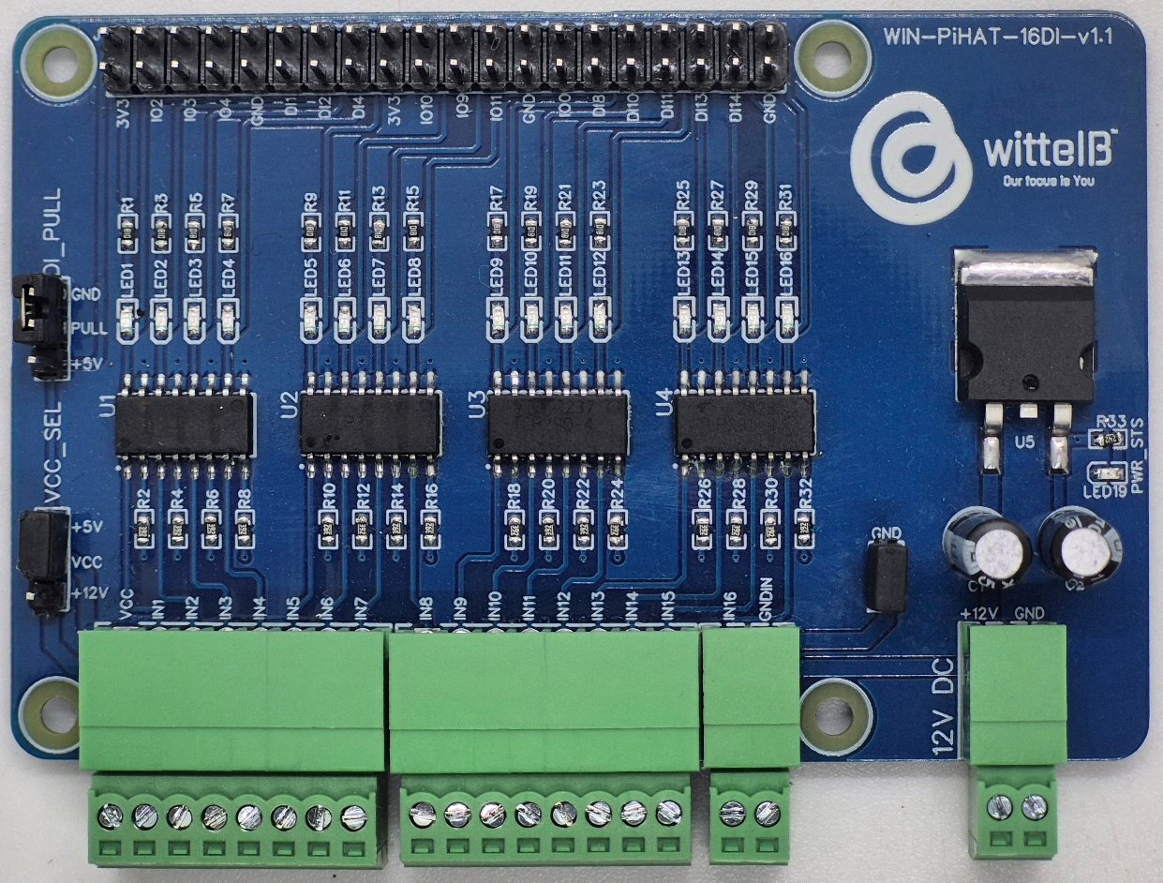
The Digital Input (DI) PiHAT is a 16-channel expansion board for Raspberry Pi 4 and CM4, offering opto-isolated signal acquisition. It protects your system by providing electrical isolation between external digital inputs and the Pi’s GPIO header, ensuring high signal integrity for industrial environments.

PiHAT features a scalable design for 4, 8, or 16 channels(DI). This flexible, population-based assembly makes it a compact and reliable solution for embedded control, monitoring, and automated industrial applications.
Specifications
Category | 16DI PiHAT
Input Type | Digital Input (12V & 5V with Reference),  Digital Input (With GND Reference),  Digital Input (80V Absolute Max. @50mA)
Channel Count | 16 Channels (Expandable Design Architecture)
Connectors | 2 of 2.54 mm Pluggable Terminal Blocks (8-Pin),  2 of 2.54 mm Pluggable Block (2-Pin),  40-Pin Raspberry Pi GPIO Header

General :–

Dimensions 56 mm L x 85 mm W
Power Input Power – 12/24V DC
Operating Temperature -30 – 80° C (-22 ~ 176°F)
Storage Temperature -20 - 70° C (-4 ~ 158°F)
Storage Humidity 5 ~ 95 % RH, non – Condensing
Certifications 

DI (Digital Inputs) :–

Digital Input channels 16
Sense Voltage 3.3 – 12V DC (Depends on the selected type of Input)
Digital Sensing Logic Logic ‘0’ = <1 VDC, Logic ‘1’ = >3.3 VDC
Isolation Optically isolated
Response Time 2 msec, Max 6 msec

Additional Features :-
Input power reverse polarity safety
ESD Safety IEC 61000-4-2, ± 30KV contact, ± 30KV air
Configuration :-

All 16DI channels operate as opto-isolated digital inputs and are directly interfaced to the Raspberry Pi GPIO header.

Input configuration and signal handling are performed through software running on the Raspberry Pi. Each input channel is initialized as a GPIO input and can be monitored using standard Raspberry Pi GPIO libraries. The input logic is active-low, with the optocoupler output pulling the corresponding GPIO pin to ground when the input signal is present.

The following are step by step guides for configuration:
- Connect the Module to +12/24V DC POWER SUPPLY.
- Connect the Board to the Raspberry Pi via header pins

Sr. No. | Digital Input | Pi GPIO | Header Pin number | Alternate Function
1 | DI1 | 17 | 11 | -
2 | DI2 | 27 | 13 | -
3 | DI3 | 23 | 16 | -
4 | DI4 | 22 | 15 | -
5 | DI5 | 24 | 18 | -
6 | DI6 | 25 | 22 | -
7 | DI7 | 07 | 26 | CE1
8 | DI8 | 05 | 29 | -
9 | DI9 | 12 | 32 | PWM0
10 | D10 | 06 | 31 | -
11 | DI11 | 13 | 33 | PWM1
12 | DI12 | 16 | 36 | -
13 | DI13 | 19 | 35 | PCM FS
14 | DI14 | 26 | 37 | -
15 | DI15 | 20 | 38 | PCM DIN
16 | DI16 | 21 | 40 | PCM DOUT
Note: Using any listed Alternate Function will disable that specific channel's ability to act as a Digital Input, as these pins can only support one hardware mode at a time.

Wiring Diagram:-
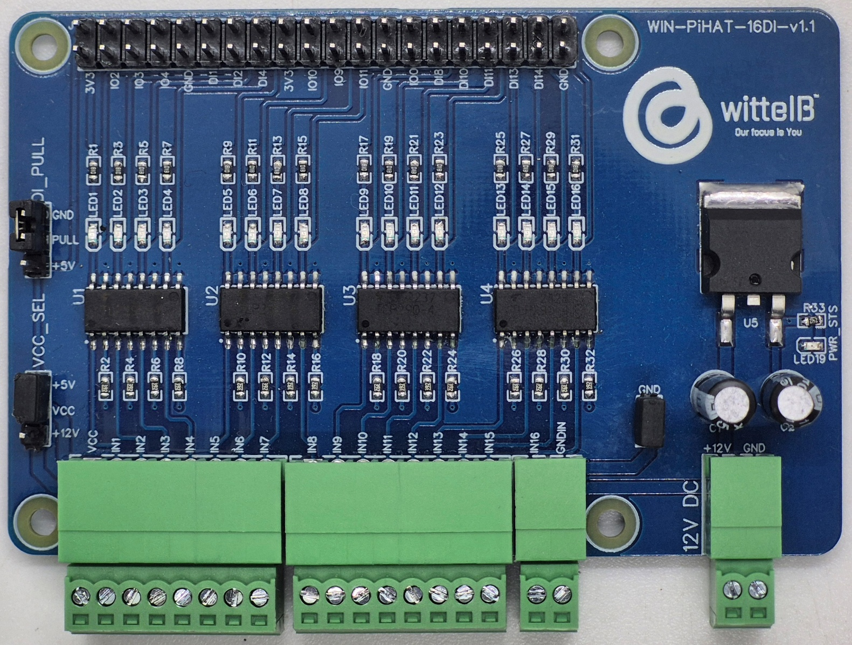
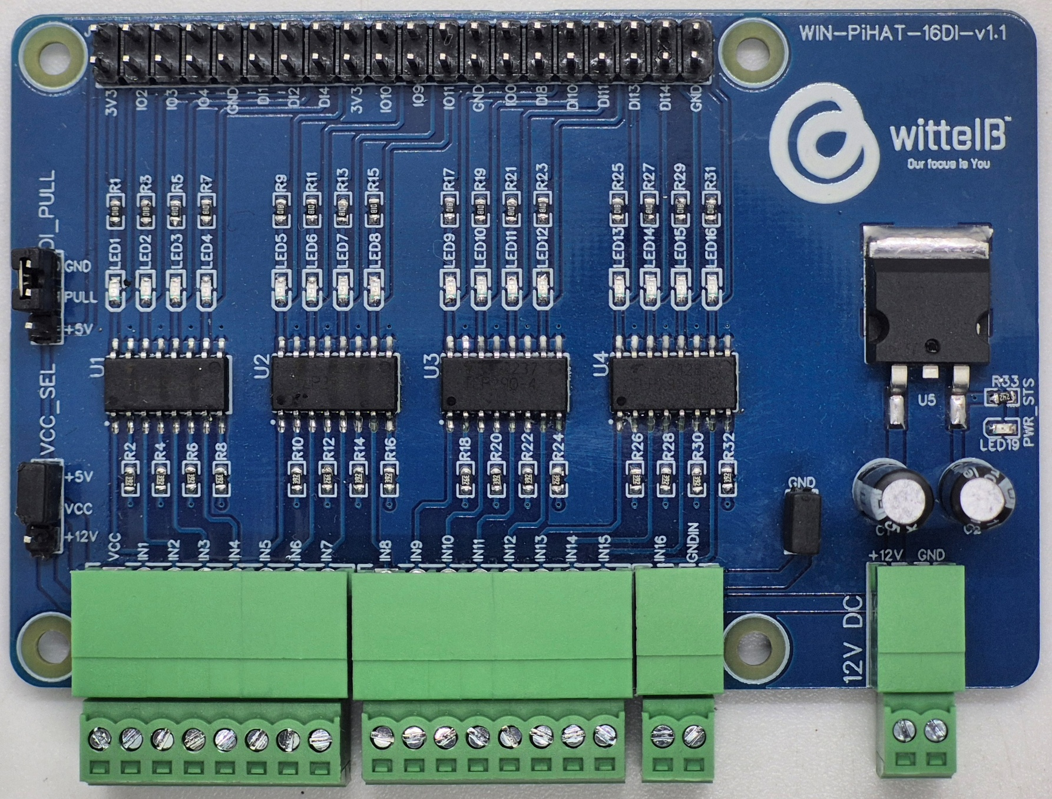
- For 5 & 12V Reference:
For Digital Input with 12V or 5V reference, VCC_SEL jumper should be connected to +12V or +5V. And DI_PULL jumper should be connected to GND.
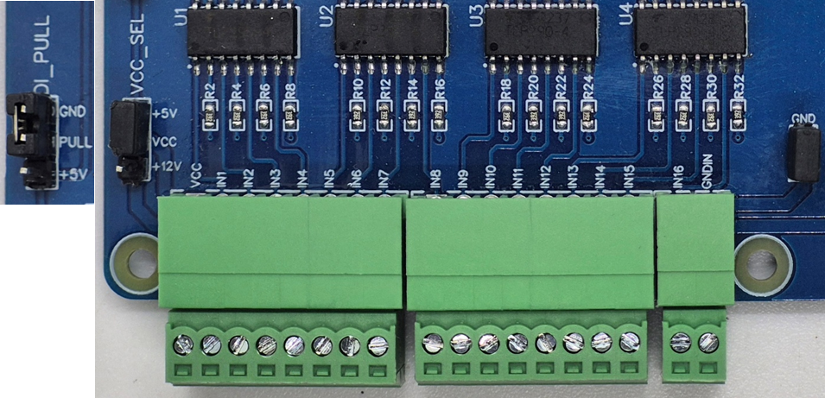
For Ground Reference:

For Digital Input with Ground reference, GND jumper should be connected. And DI_PULL jumper should be connected to +5V.


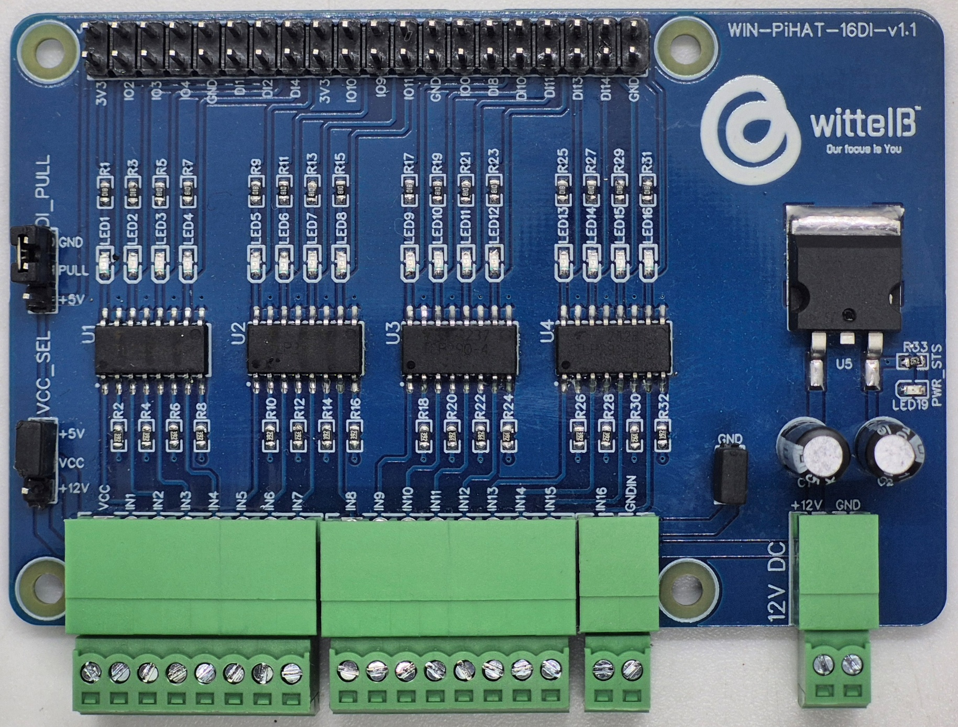
- For External Reference Voltage:
For Digital Input with External Supply, VCC_SEL and GND jumper are Disconnected. And as per requirement if DI is with pull-up then DI_PULL jumper is connected to +5V and DI is connected to GNDIN. And if DI is with pull-down then DI_PULL jumper is connected to GND and the DI is connected to VCC.
Sample Test Code:
- WIN-PiHAT-16DI

Hardware Interface & Connector Layout:

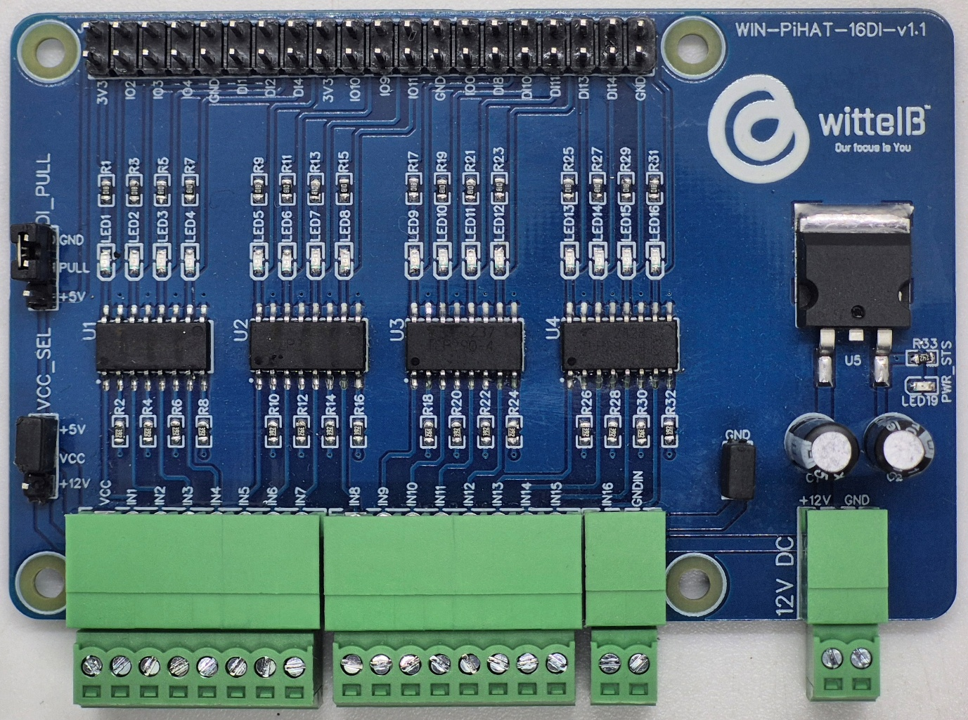
40 pin GPIO Headers
DI PULL-UP & PULL-DOWN

5 & 12V Reference
DI Input 01 to 16
GND for Digital I/p
Ground Reference
12/24V DC Supply
VCC for Digital I/p

40
39
2
1
Contact us: -

Augmatic Technologies Pvt. Ltd.,
Plot no 6, Shah Industrial Estate II,
Kotambi,
Vadodara – 391510.
Email – Sales@wittelb.com

